Relationship Diagram

Relationship :
- Movie_genre -- Many-to-Many relationship between movie and genre tables via movie_genre

Parent Table Name: Movie Child Table Name: Genre
movie_id_Pk
movie_title
movie_release_dt
movie_duration
movie_description
movie_genre_id_Pk
movie_genre_type

Child Table Name: Movie_Genre
movie_id_Fk
movie_genre_id_Fk

- Movie -- > One-to-Many relationship between movie and media

Parent Table Name: Movie Child Table Name: Movie_media
movie_id_Pk
movie_title
movie_release_dt
movie_duration
movie_description
media_id_Pk
movie_id_Fk
media_type
media_url
movie_id_Pk
movie_title
movie_release_dt
movie_duration
movi_description

- Movie -- > Many-to-Many relationship between movie and review via user

Parent Table Name: Movie Child Table Name: Review
movie_id_Pk
movie_title
movie_release_dt
movie_duration
movie_description
movie_review_id_Pk
movie_id_Fk
user_id_Fk
movie_rating
movie_review_text
movie_review_date
movie_id_Pk
movie_title
movie_release_dt
movie_duration
movi_description

Parent Table Name: User
user_id_Pk
user_name
email

- Movie -- > Many-to-Many relationship between movie and artist via artist_role_movie
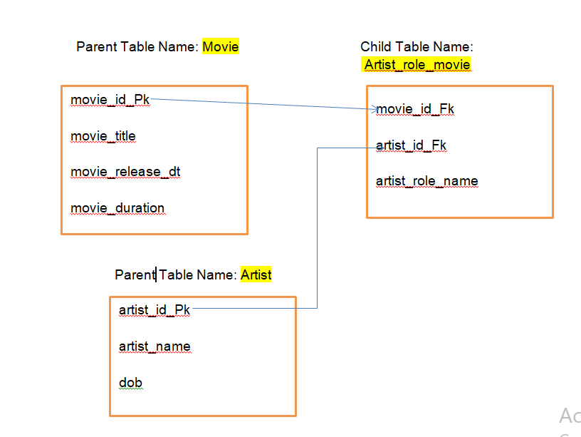

- Artist -- > Many-to-Many relationship between skill and artist via artist_skill

Parent Table Name: Artist Child Table Name: Skill
artist_id_Pk
artist_name
dob
bio

artist_skill_id_Pk
artist_skill_name

Child Table Name: Artist_skill
Artist_id_Fk
artist_skill_id_Fk

- User -- > Many-to-Many relationship between user and review

Parent Table Name: Movie Child Table Name: Review
movie_id_Pk
movie_title
movie_release_dt
movie_duration
movie_description
movie_review_id_Pk
movie_id_Fk
user_id_Fk
movie_rating
movie_review_text
movie_review_date

Parent Table Name: User
user_id_Pk
user_name
email

Explanation :
Requirements | Tables Used | Relationship
Movie should have multiple media(Video or Image) | movie, media | One-to-Many
Movie can belongs to multiple genre | movie, genre tables, movie_genre | Many-to-Many
Movie can have multiple reviews and Review can belongs to a user | movie, review, user | Many-to-Many
Artist can have multiple skills | skill, artist, artist_skill | Many-to-Many
Artist can perform multiple role in a single film | movie, artist, artist_role_movie | Many-to-Many

